**Abstract**

A Tourist Service means the provision of services in travel, transportation, accommodation, meals and drinks, entertainment, information, guidance and other services to satisfy the needs of tourists. Tourism means people travelling for fun and adventure, it includes activities such as sightseeing and camping. People who travel for fun are called “tourists”. Places, where many tourists stay, are sometimes called “resorts”. Places that people go to for tourism are called tourist destinations. Tourism comprises the activities of persons travelling to and staying in places outside their usual environment for not more than one consecutive year for leisure, business or other purposes. Tourism boosts the revenue of the economy, creates thousands of jobs, develops the infrastructure of a country, and plants a sense of cultural exchange between foreigners and citizens.

**Introduction**

Bangladesh’s tourist attractions include historical monuments, resorts, beaches, picnic spots, forests and tribal people, and wildlife of various species. Activities for tourists include angling, water skiing, river cruising, hiking, rowing, yachting, and sea bathing.

We enjoy the slow and peaceful breakfasts, the long walks, the new experiences, places, people and memories. They make us feel happy we are alive. No wonder! Travelling seems to combine most of the habits of healthy people. What are the advantages of travelling? Why is travelling important? Scientists have proven that travelling is good for both your body and your mind! Perhaps this is why we love it. Because we feel that a few minutes in the sun raise our vitamin D levels and improve our mood. Vitamin D has its health benefits too - it is good for our hearts. The importance of travel ranges from lowering the chances of heart disease to relieving stress and anxiety. On top of the health benefits, travel can also enhance your creativity, your sense of happiness and satisfaction.

In the northern part, comprising the Rajshahi division, there are archaeological sites, including the temple city Puthia in Rajshahi; the largest and most ancient archaeological site, Mahasthangarh in Bogra; the single largest Buddhist monastery, Paharpur in Naogaon; the most ornamental terracotta Hindu temple, Kantaji Temple, and many Rajbari’s or palaces of old zamindars. In the southeastern part, which is the Chittagong Division, there are natural and hilly areas like the Chittagong Hill Tracts, along with sandy sea beaches. The most notable beach, in Cox’s Bazar, is a contender for the title of the longest unbroken sandy sea beach in the world. In the southwestern part, mainly the Khulna Division, there is the Sundarbans, the largest mangrove forest in the world with the royal Bengal tiger and spotted deer. The historically and architecturally important sixty-domed mosque in Bagerhat is a notable site. In the northeastern part, of the Sylhet division, there is a green carpet of tea plants on small hillocks. Natural reserved forests are great attractions. Migratory birds in winter, particularly in the haor areas, are also very attractive in this area.

So, this project will help the tourist to find resorts, information about their interesting resorts and travel and hotel information nearest the resorts.

**Problem Statement**

Travelling is going from one place to another. It is one of those activities which is loved by everyone. It brings joy and happiness. People travel to places with their family and friends and it makes them feel relaxed. There are several things which tell that travelling is very important. When one travels, one can see new places. With travelling, one can explore different places which one has not seen before. One can meet new people there and can talk to them. One can share their stories and can know about their lifestyle. Different places also have different foods which can be enjoyed. When someone travels, he/she gets to know about a new culture and also new languages. Each place has different festivals and traditions. People speak different languages which one can learn to speak. For example, In India, people in Bengal speak the Bengali language, In Odisha, people speak the Odia language and in Andhra Pradesh, people speak Telegu. Travelling also lets a person experience different physical features of different places. One can enjoy Sea waves in one place or one can enjoy snowfall in another place. Some places have jungles, mountains, and waterfalls and other places have huge buildings, wonders of the world, big industries or malls. Not just this, travelling is also important for mental health. Improving your mental power. If you have chronic stress, your memory and goal-setting abilities are negatively affected. Taking time to go somewhere and get away from work can help you feel more productive and focused when you get back. This is because your brain needs time to rest. Increasing your creativity. Getting out and exploring the world can boost your creativity. People who travel more can come up with diverse ideas. Exposure to new cultures, making international friends, studying new languages, and taking in different types of food and music have been linked to better problem-solving skills. Travel helps you see the world in a new way.

But often we try to go on a tour and enjoy ourselves we don't know which places we want to visit or many of us don’t know which place is were. Maybe we are in Khulna but don’t know where the Sundarbans are or how much it will cost to visit the place so often which ends up happening if we don’t go on a tour simply because of these reasons. But it will be very beneficial if we could see where the travel places were based on the division that we are in so we can visit them if its fits our budget. Because of this, we came up with the idea that we need to develop a website where the users will be able to find the location of a tour place based on their location. Also, they will be able to find the nearest location of the tourist places that are there if they go on a tour place. For example, if they were to visit the Coxs Bazar then they should also be suggested to visit St. Martin Island because they are very close by and one should get the privilege to visit both of them. Especially if they are from the north of Bangladesh and want to go to the south just to visit the place.

**Modules**

**Log in:**

The act of logging in to a database, mobile device, or computer, especially a multiuser computer or a remote or networked computer system. a username and password that allows a person to log in to a computer system, network, mobile device, or user account.

**Registration:**

The module Registration is a Moodle activity add-on for the registration of users to comment or to book any package

**Admin:**

An administrator is a person who ensures that an organization operates efficiently. Their specific duties depend on the type of company, organization, or entity where they work. Above all, administrators need to be highly organized and have good communication skills.

**Users:**

A user is someone who employs or uses a particular thing, like a user of nicotine or a user of an internet site.

**Add Places:**

Admin Will be able to add new places

**Add Hotels:**

Admin will be able to add hotels

**Add Restaurant:**

Admin will be able to add restaurants

**Add Package:**

Admin will be able to add packages of different tour packages

**Add 360 Video:**

Admin will be able to add 360 videos of a tour place or a hotel

**Add Food:**

Admin will be able to add food

**Advantages**

1. Efficiency: One can easily find out the tour spot according to division or district wise.
2. Represent our country: Anyone all over the world can visit the website and know about tourist spots in Bangladesh.
3. Cost-free: All services are totally cost-free.
4. Entertainment: Registered users can write posts in our community section. Users also can react to others’ posts.
5. Vehicles: Visitors will get information about how to go to his/her selected tour spot and what kind of transport is required. This information provides our travel agencies partner.
6. Hotels: If anyone wants to know information about any residential or non-residential hotel in the vicinity (nearest) of the tour spot, they will get this information from our website.

**Disadvantages**

1. Vehicles: Firstly, we connect with some travel agencies but we will not give these services.
2. Hotels: Also, we connect with some hotel agencies or hotel service providers but we will not give this service to our site first.

**Features**

1. Login system for Teachers.
2. Create a new Department.
3. Create new Courses.
4. Assign Course to Department.
5. Assign Teacher to Course.
6. Add Attendance for a particular Course.
7. Enroll students to Course Show Students Attendance Report.

**Use-Case Diagram**

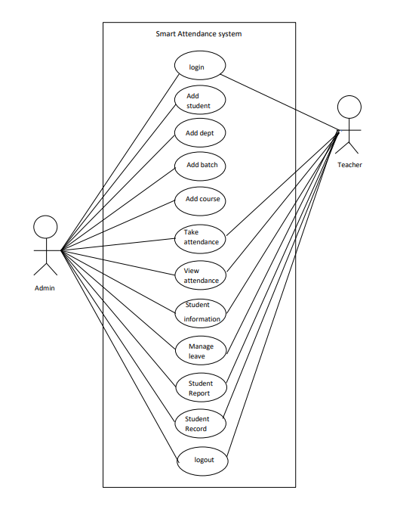

Figure 1: Use Case Diagram

**ER diagram**

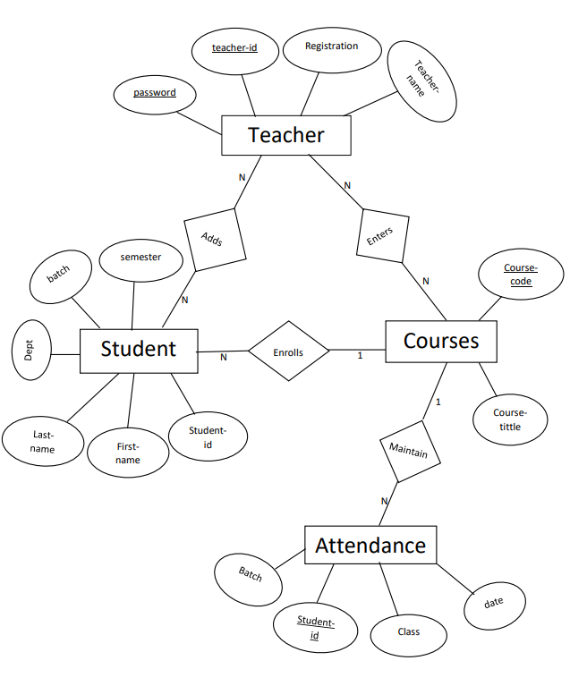

Figure 2: ER Diagram

**User interface Snapshots**

1.LoginPage: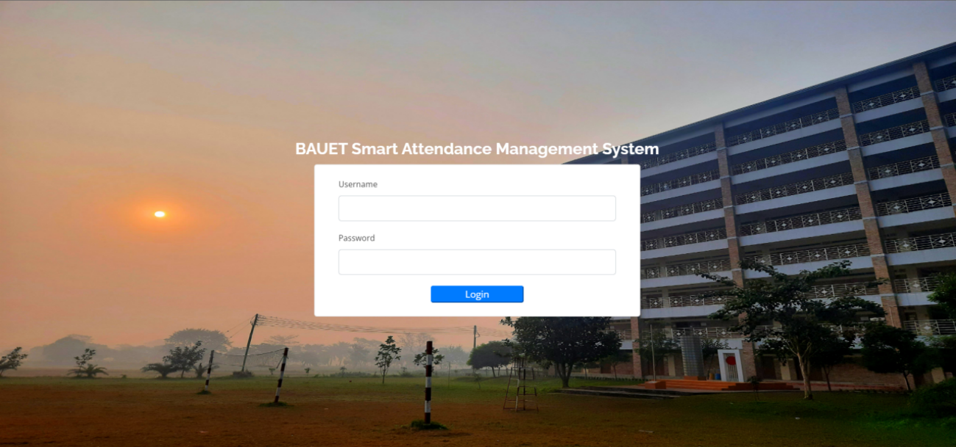

Figure 3: Login Page

1. Welcome Page:

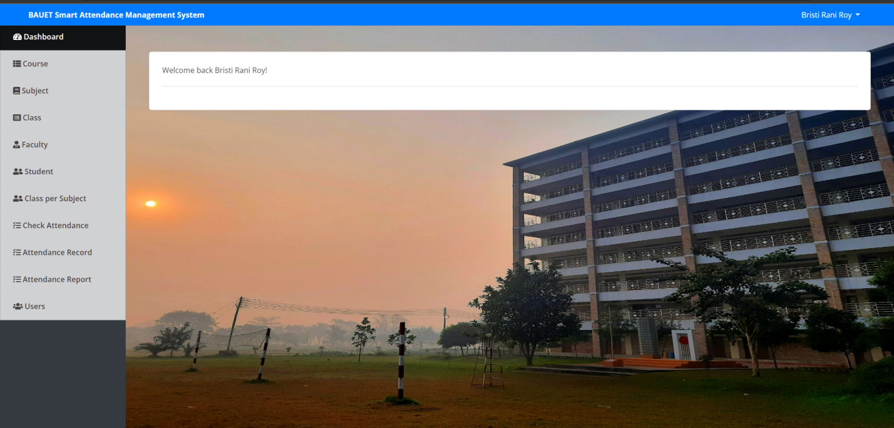

Figure 4: Welcome Page

1. Course Form:

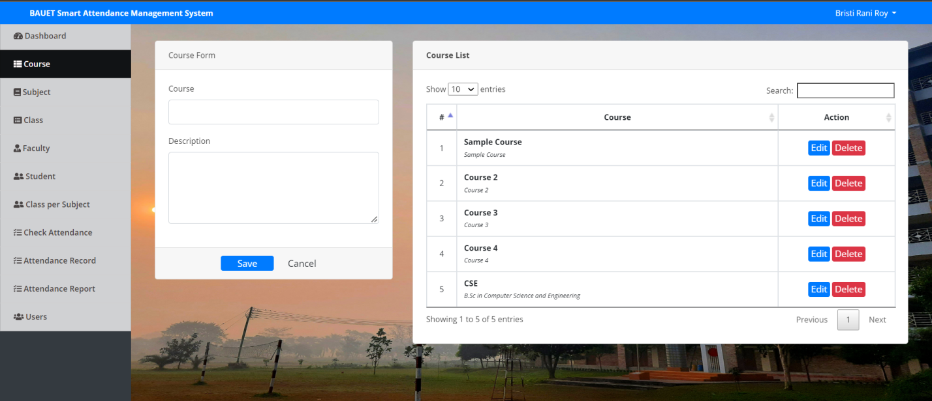

Figure 5: Course form

1. Add Subject:

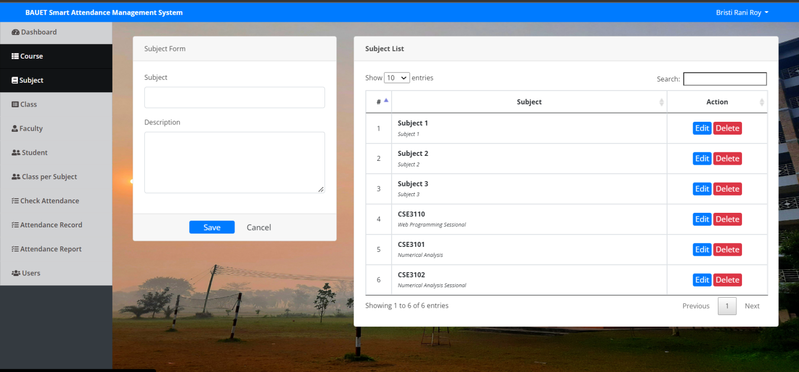Figure 6: Add Subject

1. Add Faculty:

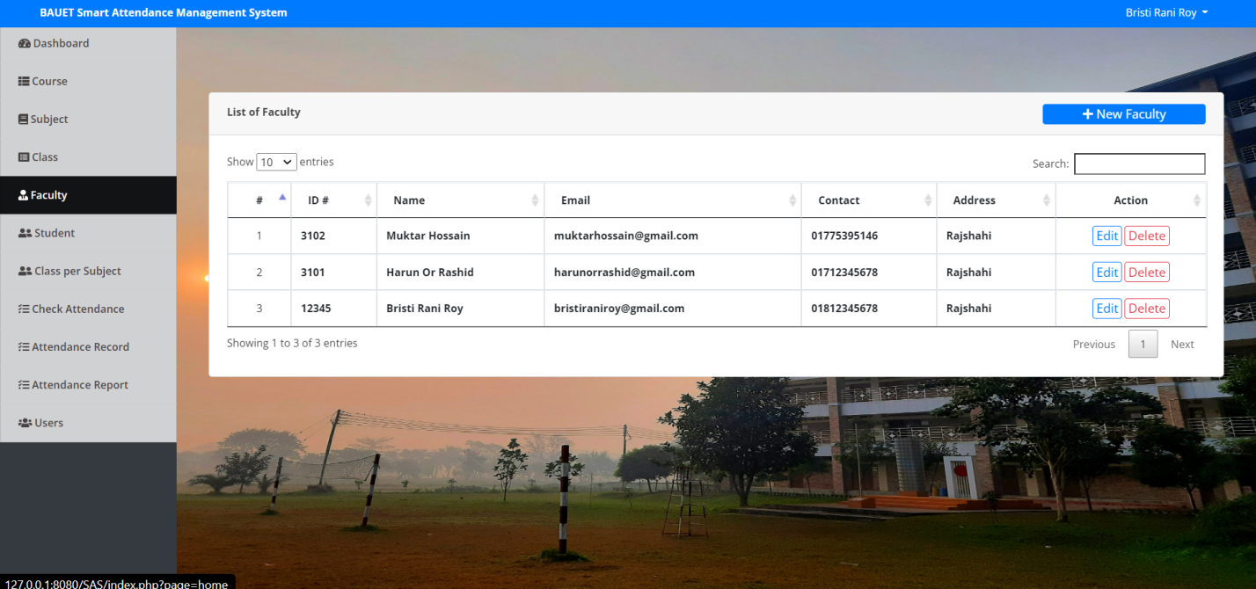

Figure 7: Add Faculty

1. Add Student:

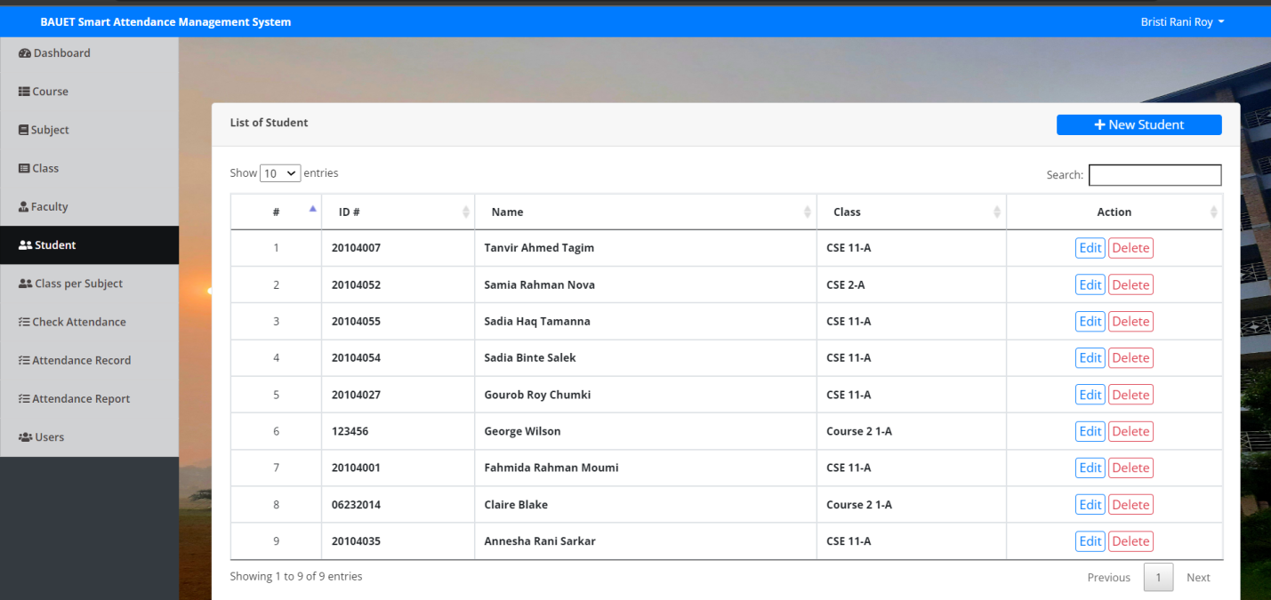

Figure 8: Add Student

1. Class per Subject:

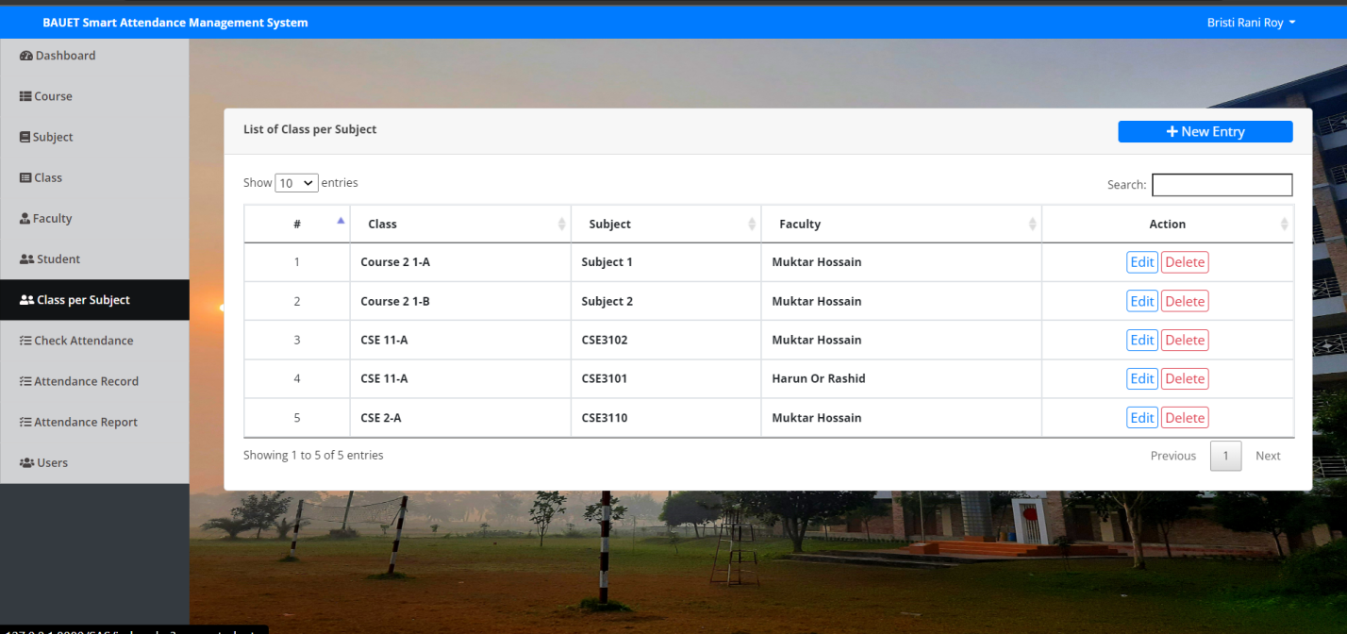

Figure 8: Class per Subject

1. Check Attendance:

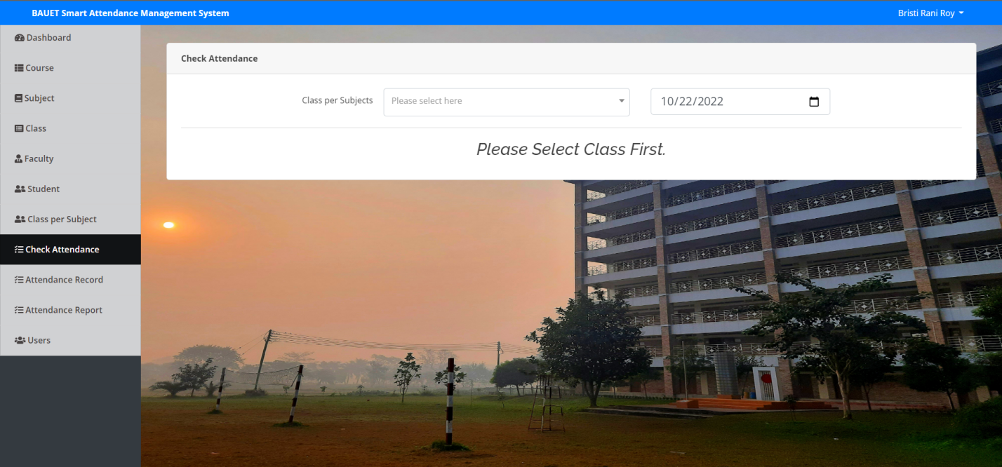  Figure 9: Check Attendance

1. Attendance Record:

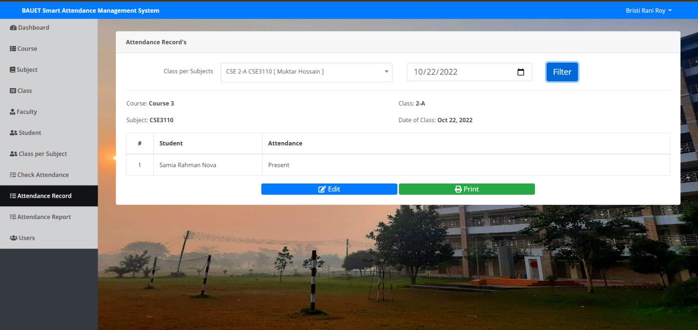

Figure 10: Attendance Record

1. Attendance Report:

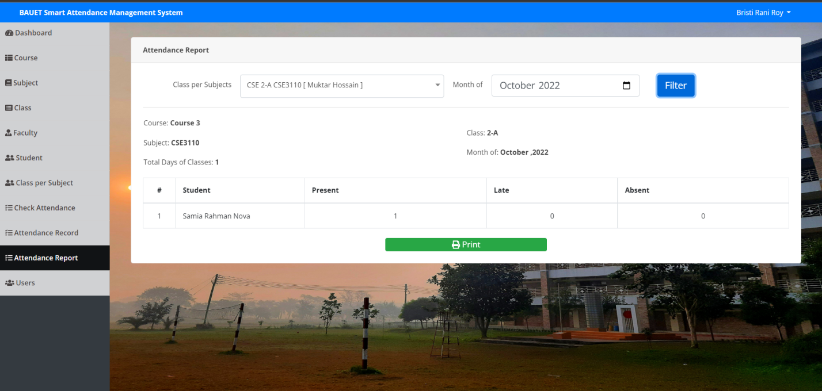

Figure 10: Attendance Report

1. Users:

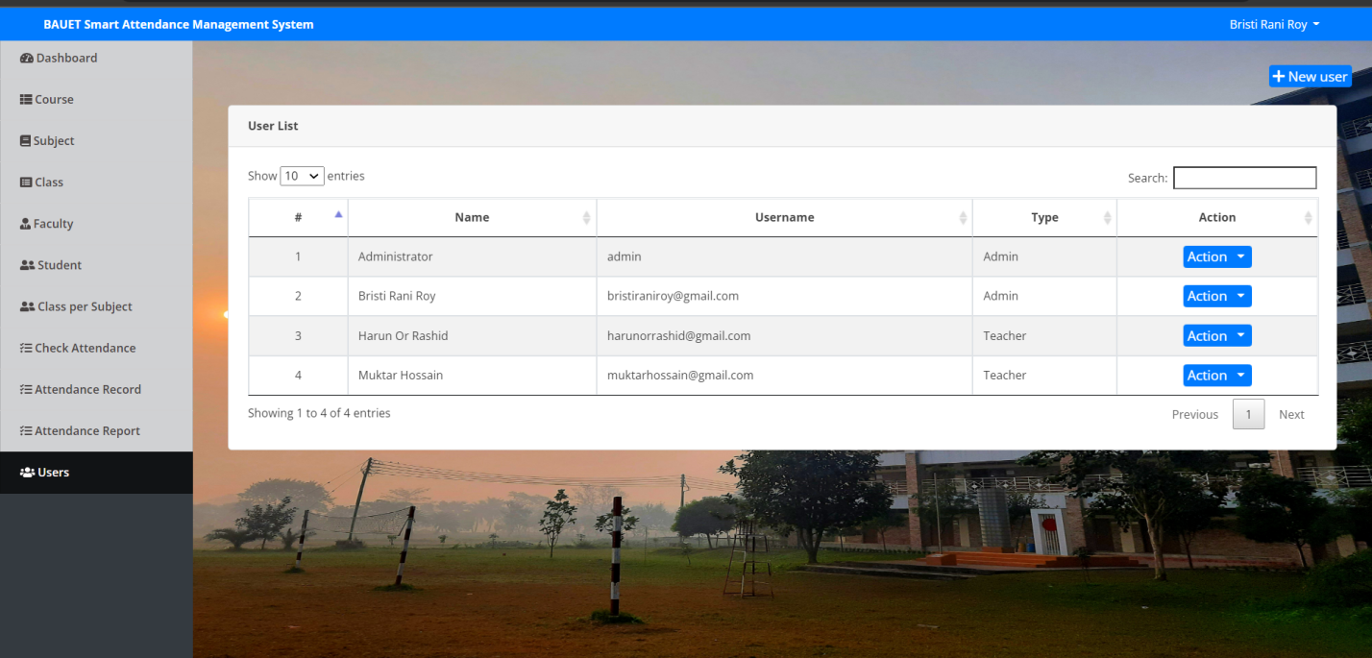

Figure 11: Users List

**Future Scope of this work**

The project has a very vast scope in the future. The project can be implemented on the intranet in the future. The project can be updated in the near future as and when the requirement for the same arises, as it is very flexible in terms of expansion. With the proposed software of database Space Manager ready and fully functional, the client is now able to manage and hence run the entire work in a much better, more accurate, and error-free manner. The following is the future scope of the project.

1. Discontinue a particular student to eliminate potential attendance.

2. Bar code Reader based attendance system.

3. Individual Attendance system with a photo using Student login.

**Conclusion**

Tracking student attendance helps teachers to keep track of student absenteeism and punctuality. It helps schools understand the average percentage of students attending school each day in the given year and helps them find ways to avoid dropouts. The Attendance Management Project has a good scope and future enhancements can be incorporated into the system effectively. The attendance system works in both online and offline modes and can be used at any time to retrieve student/admin attendance information. Further, the provision of valid user id (user ID and password) has made the system more secure and reliable. Methods of the project have been described so that one can easily understand the project. We can see that project is working in easy way. Moreover, by seeing the methods, one can know the inner work and the description of the work. So it is a very important part to know the project and do the project smoothly.

**References**

1. http://www.w3schools.com/asp.net/
2. http://www.cramerz.com/aspdotnet
3. http://www.dotnetspider.net/
4. http://www.stackoverflow.com
5. http://www.codeproject.com